**1. Abstract of your Idea:**

 Automation has created a bigger hype in the electronics. The major reason for this hype is automation provides greater advantages like accuracy, energy conversation, reliability and more over the automated systems do not require any human attention. Any one of the requirements stated above demands for the design of an automated device. The energy conversation is very important in the current scenario and should be done to a maximum extent where ever it is possible.

**2. Objectives & Significance:**

Street lighting provides a number of important benefits. It can be used to promote security in urban areas and to increase the quality of life by artificially extending the hours in which it is light so that activity can take place.

**3.Background of the Idea:**

A **street light**, **light pole**, **lamppost**, **street lamp**, **light standard**, or **lamp standard** is a raised source of light on the edge of a road or path. Similar lights may be found on a [railway platform.](https://en.wikipedia.org/wiki/Railway_platform) When urban [electric power distribution](https://en.wikipedia.org/wiki/Electric_power_distribution) became ubiquitous in developed countries in the 20th century, lights for urban streets followed, or

sometimes led.Many lamps have lightsensitive [photocells](https://en.wikipedia.org/wiki/Photocell) that activate the lamp automatically when needed, at times when there is little-to-no ambient light, such as at dusk, dawn, or at the onset of dark weather conditions. This function in older lighting systems could be performed with the aid of a [solar dial](https://en.wikipedia.org/wiki/Solar_dial)

**4.Detailed Problem Description:**

* Every embedded system requires dc voltage and that that will be 5v supply
* We are getting 230v, 50 Hz in our house hold applications. We can be used to operate the home appliances like T.V, cooler, fan, light’s
* Digital electronic devices need digital supply and we can get supply from regulated power supply block

**5.Proposed Innovative Solution and Methodology:**

* A microcontroller is a small computer on a single integrated circuit consisting of a relatively simple CPU combined with support functions such as a crystal oscillator, timers, watchdog timer, serial and analog I/O etc.
* Microcontrollers are also used in scientific, high technology, and aerospace projects.
* Microcontrollers are designed for small or dedicated applications.
* Some microcontrollers may operate at clock rate frequencies as low as 4 kHz, as this is adequate for many typical applications, enabling low power consumption (mill watts or microwatts)
* Microcontrollers are used in automatically controlled products and devices, such as automobile engine control systems, remote controls, office machines, appliances, power tools, and toys. By reducing the size and cost compared to a design that uses a separate microprocessor, memory, and input/output devices, microcontrollers make it economical to digitally control even more devices and processes.
* A microcontroller can be considered a self-contained system with a processor, memory and peripherals and can be used with an embedded system.

**6.Design and Modeling (Software or Hardware) of the proposed solution:**

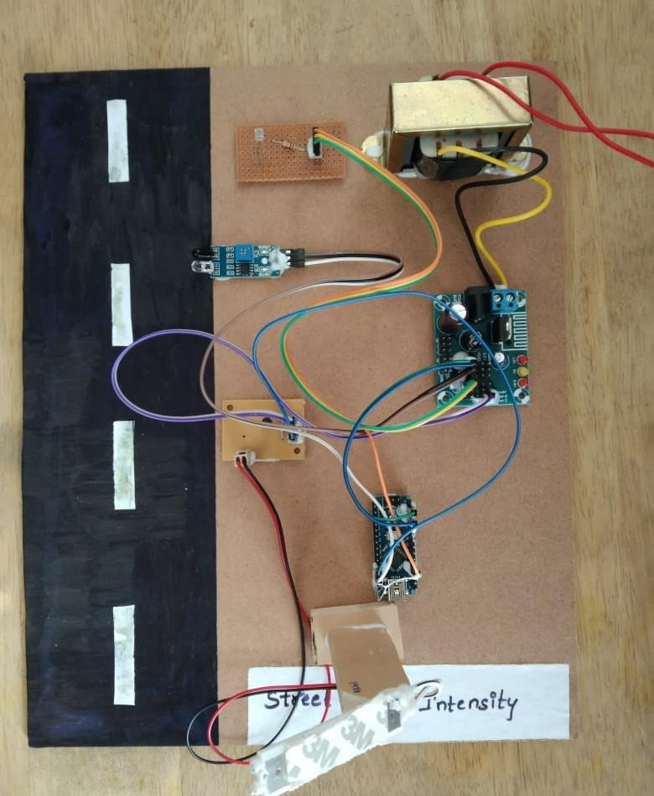

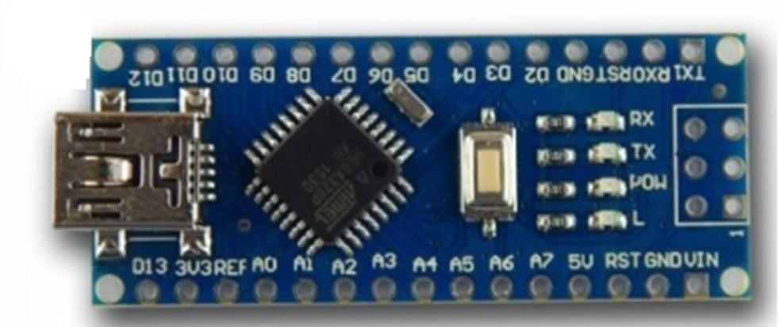

1. **Detailed description of the Prototype or Product:**  The controlling device of the whole system is an arduino nano which is interface with LDR sensor, LED street lights, and IR sensor. This project consist of LDR to detect the day/night time based on that it will control the intensity of the street light.IR sensor is used to detect the vehicle. When the IR sensor detects the vehicle then the microcontroller will switch on the street lights with high intensity after passing the vehicle street lights will glows on 50% intensity. To achieve this task microcontroller is loaded program written in embedded C language.A photo resistor or light dependent resistor or cadmium sulfide (CdS) cell is a resistor whose resistance decreases with increasing incident light intensity. It can also be referenced as a photoconductor.A photo resistor is made of a high resistance semiconductor. If light falling on the device is of high enough frequency, photons absorbed by the semiconductor give bound electrons enough energy to jump into the conduction band. The resulting free electron (and its hole partner) conduct electricity, thereby lowering resistance.

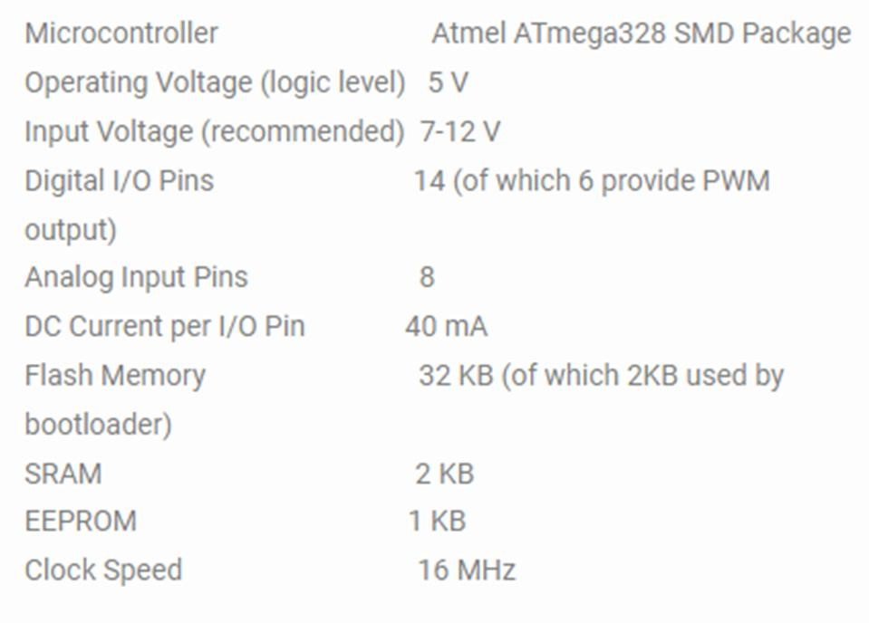

**8.Details of the deployment of product:**

The controlling device of the whole system is an arduino nano which is interface with LDR sensor, LED street lights, and IR sensor. This project consist of LDR to detect the day/night time based on that it will control the intensity of the street light.IR sensor is used to detect the vehicle. When the IR sensor detects the vehicle then the microcontroller will switch on the street lights with high intensity after passing the vehicle street lights will glows on 50% intensity. To achieve this task microcontroller is loaded program written in embedded C language.

 The energy conversation is very important in the current scenario and should be done to a maximum extent where ever it is possible. Energy can be effectively conserved if we can control the street lights on the highways by glowing them only when there is traffic on the road, and this is all most impossible to detect the arrival of a vehicle manually without the presence of light. So in this situation we should think about a system which is capable of sensing the arrival of vehicle using IR sensor and turn ON/OFF the lights as soon as the vehicle leaves the area.

1. **Outcomes & Scope for the future extension:** 
   * Low cost
   * User friendly

* + Easily available in market
  + We can reprogram it up to 1000 times
  + Less power consumption  Streets .
  + Station.
  + School .
  + The Junction Of Many Roads.
  + Main Cities.
  + Multi-lane Control.
  + Echo-friendly.
  + Waste of energy reduction.
  + Less maintenance cost.
  + ultra low noise.
  + An energy efficient streetlight system was developed.
  + Automatic street lights using LDR.
  + Vehicle presents using IR sensor.